Systems Analysis
Major Assignment
CSI1241

Requirements Specification
Version: 3.1.0
Prepared by:
To Be Confirmed
Submitted to:
Priya Rabadia

Tutorial: ES Off-campus

Student no. | Student name:
10371381 | Martin Ponce
10359993 | Francois Pero
10372148 | Adam Johnson
10378977 | Greg Snader

Date of submission:
20th October 2014

Distribution List

Who | What (hard/soft copy) | Version | When
Priya Rabadia | Soft copy | 2.3.0 | 8/10/14
Dr. Mike Johnstone | Soft copy | 3.1.0 | 20/10/14
Martin Ponce | Soft copy | 0.1.0 | 20/8/14
Francois Pero | Soft copy | 0.3.0 | 27/8/14
Adam Johnson | Soft copy | 0.3.0 | 27/8/14
Greg Snader | Soft copy | 0.3.0 | 27/8/14

Modification History

Who | What | Version | When
Martin Ponce | Initial version. Added functional, non-functional requirements, Assumptions and Out-of-scope. Added glossary terms. | 0.1.0 | 20/8/14
Martin Ponce | Added functional, non-functional requirements, assumptions and out of scope. Added glossary terms. Modified list format from unordered to ordered. Updated TOC. | 0.2.0 | 21/8/14
Martin Ponce | Rewrote functional, non-functional requirements, assumptions and out-of-scope for the development of application. Updated TOC. Updated References. | 0.3.0 | 25/8/14
Francois Pero | Added introduction and assumption 4.1.1 point 4. | 0.4.0 | 27/8/14
Adam Johnson | Added Project Scope, Glossary Terms, Modified Introduction. Minor edits to Sections 3.0 & 4.0 | 0.5.0 | 29/8/14
Martin Ponce | Defined EmployeeID as employee unique identifier. | 0.5.1 | 29/8/14
Martin Ponce | Updated and reformatted functional and non-functional requirements per Priya’s feedback. Removed APP from glossary. | 0.6.0 | 1/9/14
Martin Ponce | Added 5.0 Use Case Diagram draft v1 and 5.2 Elaborated Use Case: Search Client Records. Added Client registration as out of scope. | 0.7.0 | 7/9/14
Greg Snader | Added Lab manager account creation to 3.3 Out of scope items, point 6. Added Use Case Diagram draft v2. | 0.8.0 | 8/9/14
Francois Pero | Added 5.1 Elaborated Use Case: Log In To Application, added 11 items to 7.1 Elementary Data Dictionary, added 7.2 Composite Data Dictionary draft. | 0.9.0 | 10/9/14
Greg Snader | Added 5.3 Elaborated Use Case: View Invoice, 5.4 Elaborated Use Case: Pay Invoice. | 1.0.0 | 12/9/14
Martin Ponce | Updated Use Case diagram to include “Pay invoice” extension points. | 1.1.0 | 12/9/14
Martin Ponce | Added 6.0 Navigation Map (draft) | 1.2.0 | 22/9/14
Martin Ponce | Added 6.1 App Screen: Log In | 1.3.0 | 25/9/14
Martin Ponce | Added 6.2 App Screen: Client Home, updated 6.0 Navigation Map draft and 9.0 References. | 1.4.0 | 26/9/14
Martin Ponce | Added 6.3 App Screen: Lab Manager Home | 1.5.0 | 29/9/14
Martin Ponce | Added 6.4 App Screen: Client Search Results. Updated 5.0 Use Case Diagram and 6.0 Navigation Map | 1.6.0 | 2/10/14
Francois Pero | Added 8.1 BRD Login and 8.2 EST Log In To Application | 1.7.0 | 5/10/14
Martin Ponce | Added more 7.1 Elementary Data Dictionary definitions, updated 7.2.1 Invoice composite, added 7.2.2 Login screen, 7.2.3 Client home, 7.2.4 Lab Manager home 7.2.5 Search client results composite definitions. Removed references to AccountID, now known as EmployeeID. | 1.8.0 | 7/10/14
Greg Snader | Added 8.5 BRD View Invoice and 8.6 EST View Invoice | 1.9.0 | 7/10/14
Martin Ponce | Added 8.3 BRD Search Client Records and 8.4 EST Search Client Records. Updated 8.1 BRD Log In To Application and 8.2 EST Log In To Application | 2.0.0 | 8/10/14
Martin Ponce | Updated app screens to match some composite data definitions, updated navigation map to match some composite data definitions, reworded some composite data definitions. | 2.1.0 | 8/10/14
Adam Johnson | Added 5.5 Elaborated use case: Request sample destruction, 8.9 BRD: Request sample destruction, 8.10 EST: Request sample destruction. | 2.2.0 | 9/10/14
Greg Snader | Added 8.7 BRD: Pay Invoice, 8.8 EST: Pay invoice. | 2.3.0 | 9/10/14
Martin Ponce | Updated document per Priya’s feedback re sections 3.1, 4.0, 5.0, 5.1, 5.4, 6.0, 6.3, 7.1. Amended 7.2.4 Lab manager home composite dictionary to reflect changes to home screen links. Updated 8.1 BRD Log In BRD, 8.2 EST Log In, 8.3 BRD Search Client Records, 8.4 EST Search Client Records. | 2.4.0 | 11/10/14
Greg Snader | Amended Extensions of 5.4.1 Elaborated Use Case Pay Invoice per Priya’s feedback. | 2.4.1 | 11/10/14
Adam Johnson | Updated 8.9 BRD Request Sample Destruction, 8.10 EST Request Sample Destruction. | 2.5.0 | 12/10/14
Greg Snader | Updated 8.5 BRD View Invoice, 8.6 EST View Invoice. | 2.6.0 | 12/10/14
Francois Peros | Created initial 10.0 LRDM version, included INVOICE entity. | 2.7.0 | 12/10/14
Greg Snader | Updated 8.7 BRD Pay Invoice, 8.8 EST Pay Invoice. | 2.8.0 | 14/10/14
Martin Ponce | Updated Non-functional requirements 3.2.3, 3.2.4, 3.2.5 and Assumption 4.1.13 | 2.8.1 | 15/10/14
Martin Ponce & Adam Johnson | 10.0 LRDM: created entities and developed relationships | 2.9.0 | 16/10/14
Greg Snader | Completed 10.0 LRDM, refined keys, attributes, relationships and logic, created missing entities. | 3.0.0 | 16/10/14
Martin Ponce & Adam Johnson | Finalised 7.0 Data Dictionaries, added LRDM composites and refined elementary definitions. | 3.1.0 | 17/10/14

TABLE OF CONTENTS | Page

1.0 INTRODUCTION 6
2.0 GLOSSARY OF TERMS 6
3.0 PROJECT SCOPE 7
3.1 FUNCTIONAL REQUIREMENTS 7
3.2 NON-FUNCTIONAL REQUIREMENTS 8
3.3 OUT OF SCOPE ITEMS 9
4.0 ASSUMPTIONS 10
4.1 Client assumptions 10
4.2 Employee assumptions 11
4.3 Application assumptions 11
5.0 USE CASE DIAGRAM 12
5.1 ELABORATION OF LOG IN TO APPLICATION USE CASE 13
5.2 ELABORATION OF SEARCH CLIENT RECORDS USE CASE 14
5.3 ELABORATION OF VIEW INVOICE USE CASE 15
5.4 ELABORATION OF PAY INVOICE USE CASE 16
5.5 ELABORATION OF REQUEST SAMPLE DESTRUCTION USE CASE 18
6.0 NAVIGATION MAP 20
6.1 App SCREEN#1 – Log In Screen 21
6.2 App SCREEN#2 – Client Home 23
6.3 App SCREEN#3 – Lab Manager Home 25
6.4 App SCREEN#4 – Search Client Results 27
7.0 DATA DICTIONARIES 28
7.1 ELEMENTARY DATA DICTIONARY 28
7.2 COMPOSITE DATA DICTIONARY 32
7.3 App screen composite definitions 32
7.4 Entity composite definitions 33
8.0 BUSINESS RULES DIAGRAMS 36
8.1 BRD OF LOG IN TO APPLICATION 36
8.2 EVENT SPECIFICATION TABLE OF LOG IN TO APPLICATION 37
8.3 BRD OF SEARCH CLIENT RECORDS 38
8.4 EVENT SPECIFICATION TABLE OF SEARCH CLIENT RECORDS 39
8.5 BRD OF VIEW INVOICE 40
8.6 EVENT SPECIFICATION TABLE OF VIEW INVOICE 41
8.7 BRD OF PAY INVOICE 42
8.8 EVENT SPECIFICATION TABLE OF PAY INVOICE 43
8.9 BRD OF REQUEST SAMPLE DESTRUCTION 44
8.10 EVENT SPECIFICATION TABLE OF REQUEST SAMPLE DESTRUCTION 45
9.0 REFERENCES 46
10.0 LOGICAL RELATIONAL DATA MODEL 47

INTRODUCTION

Cryo Cell Corporation (CCC) wants to develop a mobile application that will enable clients and staff to perform a number of key tasks through their Apple iPhone devices. Development of the application offers CCC a number of potential benefits by improving overall customer satisfaction and building the brand. The application will provide better support and improve accessibility for clients. It has the potential to improve sales by exposing clients to additional services provided by CCC. It also has the potential to increase cash flow by improving the turnaround time on invoice payment. The application also offers benefits internally by improving staff efficiency and reducing the administrative load.

GLOSSARY OF TERMS

Term | Definition
CCC | Cryo Cell Corporation, the client requesting the system to be built.
EmployeeID | Unique 5 digit identifier assigned to employee when a user account is created by the Laboratory Manager.
SampleID | Unique number assigned to each sample collected from clients.
FacilityID | Unique 3 character identifier for each of CCC’s storage facilities.
FridgeID | Identifier for the storage refrigerator at a CCC storage facility. There are up to 99 fridges at any single CCC storage facility.
CSC | Cryogenic Sample Container, holds up to 16 samples and is used to store client sample for storage. Each CSC has a unique identification number.
CSC Matrix Position | Each CSC can hold up to 16 samples. A location of a particular sample stored in a CSC is identified by the CSC Matrix Position.
CCC Human Resources system | CCC’s existing system which contains a record of all current staff members and their assigned job description.
APPs | Australian Privacy Principles regulate the handling of information by Australian government agencies and some private sector organisations.
SDK | Software Development Kit is a set of software development tools that allow the creation of applications.
Corona | An SDK from Corona Labs Inc. that allows developers to build mobile applications for Apple iOS and Android devices.

PROJECT SCOPE

The application will enable existing CCC clients and staff to perform a number of key tasks through their Apple iPhone devices. Existing CCC clients will be able to view services, check sample status, request sample destruction, pay invoices and send enquiries, while CCC staff will be able to search for samples, retrieve client details and examine audit records. The application will be developed using the Corona SDK which will allow future versions of the application to support Android devices.

FUNCTIONAL REQUIREMENTS

The proposed iPhone application provides functions for both clients and employees. These functions are categorized below.

3.1.1 Client must be able to browse a listing of services provided by CCC

3.1.2 Client must be able to request their sample to be destroyed

3.1.3 Client must be able to view the status of their sample

3.1.4 Client must be able to securely view and pay invoices from CCC

3.1.5 Client Account Manager must be able to view client records only

3.1.6 Laboratory Technician must be able to view sample data and sample location records only

3.1.7 Laboratory Manager must be able to view sample data and sample location records

3.1.8 Laboratory Manager must be able to access CCC’s internal audit system and view the system log of creation, modification and deletion of client and sample records

3.1.9 Laboratory Managers must be able to create a new user accounts for employees who have been verified to exist within CCC’s HR system

NON-FUNCTIONAL REQUIREMENTS

3.2.1 Existing Client user must be able to log in to the application using their CCC client user account login details

3.2.2 Existing CCC Employee user must be able to log in to the application using their employee user account login details

3.2.3 Client must be able to pay invoice via credit card

3.2.4 Credit card payment is only accepted via MasterCard or Visa

3.2.5 Client must be able to select direct debit payment method

3.2.6 iPhone application must be developed using Corona SDK

3.2.7 The iPhone application must provide encapsulation for both user types:
- A client user type must not be able to access employee functions
- An employee user type must not be able to access client functions

3.2.8 The iPhone application must provide the client with a secure online form to complete to confirm the destruction of their sample, refer to case study for current process

3.2.9 The iPhone application must notify CCC that the confirmation form has been completed to allow for prompt destruction of sample

3.2.10 The iPhone application must interface with CCC’s internal audit system and record the following data when a client or sample data record is viewed by any employee account type:
- Accessed ClientID or SampleID
- EmployeeID
- Date & Timestamp
- Function (access/edit/create/delete)

OUT OF SCOPE ITEMS

3.3.1 Client registration

3.3.2 Generate printed invoices

3.3.3 Interfacing with bank/s to generate refunds

3.3.4 Track shipping

3.3.5 Access requirements for employees that are not Client Account Managers, Lab Technicians and Lab Managers

3.3.6 Monitoring storage climates and temperatures

3.3.7 The development of an iPad version of the application

3.3.8 The development of the application on the Android platform

3.3.9 The development of the application on desktop environments ie. Windows/OSX

3.3.10 Modification of CCC’s existing systems and processes

ASSUMPTIONS

Client assumptions

4.1.1 Client registration is assumed to occur outside of the iPhone application on CCC’s website

4.1.2 Client registration is assumed to create data records and an online account for the client that can be utilised by the iPhone application

4.1.3 Client registration is assumed to be recorded by CCC’s internal audit system

4.1.4 The information and questionnaire provided by the client is reviewed by an employee of CCC before client is accepted

4.1.5 It is assumed that rather than emailing clients a link to a secure form to confirm their sample destruction request as outlined in the case study, the secure form will be issued to the customer from within the iPhone application where it can be completed

4.1.6 Sample data records are assumed to contain fields that indicate the physical and testing status of client samples which can be used by the iPhone application

4.1.7 It is assumed that there is no GST component in the invoice

4.1.8 It is assumed that invoices are only generated and issued electronically

4.1.9 It is assumed that clients are warned if their payment is overdue and sample is to be destroyed

4.1.10 It is assumed that clients are notified when sample is destroyed for non-payment

4.1.11 It is assumed that refunds are processed externally from the proposed iPhone application

4.1.12 It is assumed that refund of pro-rata annual fee is also provided to clients after requesting their sample to be destroyed and have cancelled their storage plan

4.1.13 It is assumed that direct debit payments are only accepted via credit card, MasterCard or Visa

Employee assumptions

4.2.1 It is assumed that roles are specified within employee user accounts during their creation by the Laboratory Manager

4.2.2 It is assumed that employee user accounts are assigned a unique EmployeeID when created by the Laboratory Manager

Application assumptions

4.3.1 It is assumed that the iPhone application will communicate with CCC’s servers securely using industry standard encryption

4.3.2 It is assumed that the iPhone application will provide the user a method to reset their password if forgotten

4.3.3 It is assumed that the iPhone application will provide the user a method to change their password when necessary

USE CASE DIAGRAM

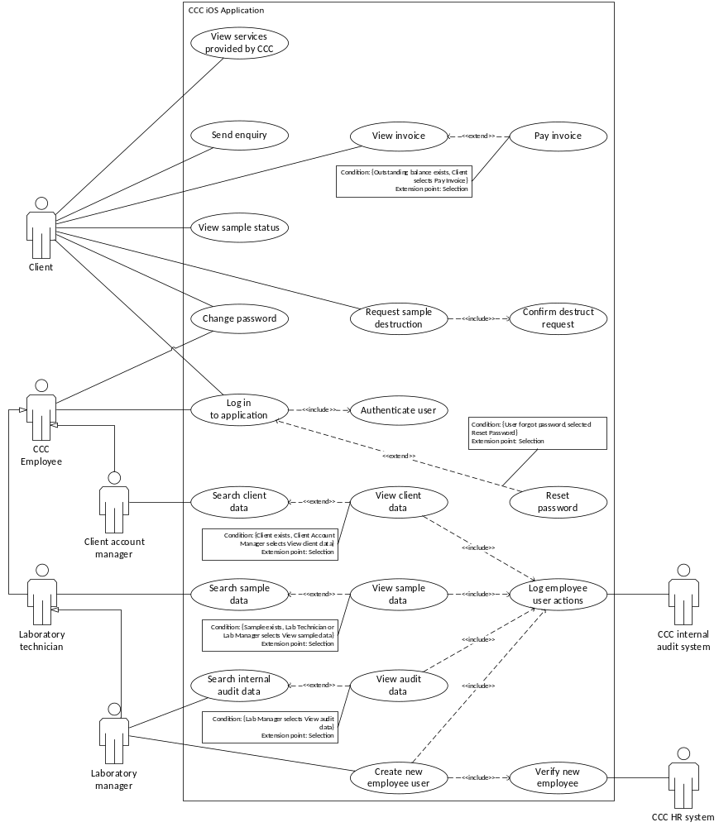

ELABORATION OF LOG IN TO APPLICATION USE CASE

Use case: Log in to application
Actor(s): Client, CCC Employee
Purpose: This use case allows both Clients and CCC Employee users to log in to the application.
Overview: Client or CCC Employee enters account details which are then authenticated by the system. If the details are correct, the system identifies the user type and provides access to the application according to the user’s type.
Preconditions: Client or CCC Employee is logged out of the application and is attempting to log in. Client must exist in client user database, and CCC Employee must exist in CCC HR System.
Postconditions: Client or CCC Employee is logged in to the system and is provided access according to their user type.

Typical Course of Events

Actor Action | System Response
1. Client or CCC Employee enters username and password  Extension point: Reset password | 2. System authenticates details  Include: Authenticate user
 | 3. If details are correct, system identifies user type, either Client or CCC Employee
 | 4. System signs in Client or CCC Employee to application according to user type

Alternative Courses

- Step 1: User may choose to reset password, go to Reset password use case.
- Step 3: If Client or CCC Employee details are incorrect and fails authentication, display message “Incorrect username and password”, go to Step 1. After 3 failed authentication attempts, use case ends.
- Step 3: If user is CCC Employee, authentication process will identify employee type and provide access to their designated functions only.

Related Use Cases

Inclusions: Authenticate user
Extensions: Reset password

ELABORATION OF SEARCH CLIENT RECORDS USE CASE

Use case: Search Client Records
Actor(s): Client Account Manager
Purpose: This use case allows the Client Account Manager to search for client records on the iPhone application
Overview: Client account manager enters client search query. If client record/s match search query, system displays search results. Client Account Manager views client record and the system logs user actions. If no client record/s match search query, display message advising that no results were found.
Preconditions: Client Account Manager has logged in successfully to the application and wishes to search for client information
Postconditions: Client Account Manager locates and views client data, and user activity is logged by CCC internal audit system

Typical Course of Events

Actor Action | System Response
1. Client account manager enters client search query | 2. System provides search query results
3. Client account manager selects search query result  Extension point: View client record | 4. System displays client data
 | 5. System logs employeeID, time/date stamp, access type and accessed clientID
6. System sends logged data to CCC internal audit system
Include: Log user actions

Alternative Courses

- Step 1: Client account manager cancels search, end use case
- Step 2: Search query provides zero results, system displays message “No results found”, return to step 1, end use case
- Step 3: Client account manager cancels search, end use case

Related Use Cases

Inclusions: Log user actions
Extensions: View client record

ELABORATION OF VIEW INVOICE USE CASE

Use case: View Invoice
Actor(s): Client
Purpose: This use case allows the client to view their current invoice.
Overview: The client selects the option to view their invoice, the system will then display the customer’s current invoice. If an outstanding balance exists, the system provides the client an option to pay. This use case concludes (or ends) when the client either cancels the viewing of their invoice, or once the client selects the option to pay the invoice.
Preconditions: The client has logged into their account successfully.
The client selects the option to view their current invoice.
Postconditions: Client is returned to the previous screen or viewing the payment options in the “Pay Invoice” use case.

Typical Course of Events

Actor Action | System Response
1. Client selects the option to view their invoice | 2. System displays most recent invoice
 | 3. If an outstanding balance exists, system provides customer option to pay the invoice
4. Client chooses to pay invoice
Extension Point: Pay Invoice

Alternative Courses

- Step 2: If no invoices exist for client, display message “No existing invoices”, use case ends.
- Step 2: Client chooses to cancel the viewing of their invoice, use case ends.
- Step 3: No outstanding balance exists, or client has previously opted to pay via direct debit instalment plan, client can only cancel the viewing of their invoice, use case ends.
- Step 4: Client chooses not to pay invoice, use case ends.

Related Use Cases

Inclusions: nil
Extensions: Pay invoice

ELABORATION OF PAY INVOICE USE CASE

Use case: Pay Invoice
Actor(s): Client
Purpose: This use case allows the client to pay their current invoice.
Overview: The client chooses to pay invoice after viewing the current invoice. Client may choose to make full payment via credit card or direct debit instalment plan. This use case concludes (or ends) when the client cancels the payment of their invoice, or once the client successfully pays the invoice amount or has elected to pay via direct debit instalment plan and has provided payment details.
Preconditions: The client has logged in to their account successfully. The client selects the option to view their current invoice. The system has identified an outstanding balance, and the client selects the option to pay their current invoice.
Postconditions: Client is returned to the homepage after successful payment is made, or returned to viewing the current invoice in the “View Invoice” use case, if payment was not made.

Typical Course of Events

Actor Action | System Response
1. Client chooses option to pay current invoice | 2. System displays most recent invoice details and amount due
 | 3. System provides client option to pay via credit card or via direct debit instalment plan
4. Client selects to pay via credit card | 5. System displays outstanding balance
 | 6. System requests client billing details and credit card type
7. Client enters required details | 8. System requests client confirmation that the details entered are correct
9. Client confirms | 10. System verifies payment details
 | 11. System accepts payment and displays payment confirmation and receipt number
12. Client acknowledges transaction confirmation and receipt | 13. System emails payment receipt to client
 | 14. System returns client to “View Invoice” use case

Alternative Courses

- Step 4: Client selects to pay via direct debit instalment plan, system displays the instalment amounts and due dates and requests client payment details. Go to step 8 and continue with use case.
- Step 4: Client chooses to cancel payment, return to “View invoice” use case.
- Step 9: Client does not confirm details are correct, return to step 7.
- Step 10: System is unable to verify payment details, display message “Payment details invalid”, return to step 7.

Related Use Cases

Inclusions: nil
Extensions: nil

ELABORATION OF REQUEST SAMPLE DESTRUCTION USE CASE

Use case: Request sample destruction
Actor(s): Client
Purpose: This use case allows the Client to request destruction of their sample.
Overview: The Client selects the option to Request sample destruction. The system displays a message asking if the Client wants to request destruction of their sample. The Client responds in the affirmative. The system displays a message asking the Client to confirm the sample destruction request. The Client confirms the request. The system displays a message confirming the sample destruction request has been sent. The use case ends once the Client has either confirmed or cancelled their sample destruction request.
Preconditions: Client has logged into their account successfully.
Client selects the option to Request sample destruction.
Postconditions: Client is returned to the application homepage after confirming or cancelling their sample destruction request.

Typical Course of Events

Actor Action | System Response
1. Client selects the option to Request sample destruction. | 2. System displays message asking Client if they want to request destruction of their sample or cancel the request.
3. Client responds that they want to request destruction of their sample. | 4. System displays confirmation form.  Include: Confirm destruct request
5. Client completes confirmation form. | 6. System displays message confirming the sample destruction request has been submitted.
 | 7. System returns Client to application homepage.

Alternative Courses

- Step 1: Sample does not exist, use case ends.
- Step 3: Client chooses to cancel their request, use case ends and Client is returned to the application homepage.
- Step 5: Client does not complete confirmation form, use case ends and Client is returned to the application homepage.

Related Use Cases

Inclusions: Confirm destruct request
Extensions: nil

NAVIGATION MAP

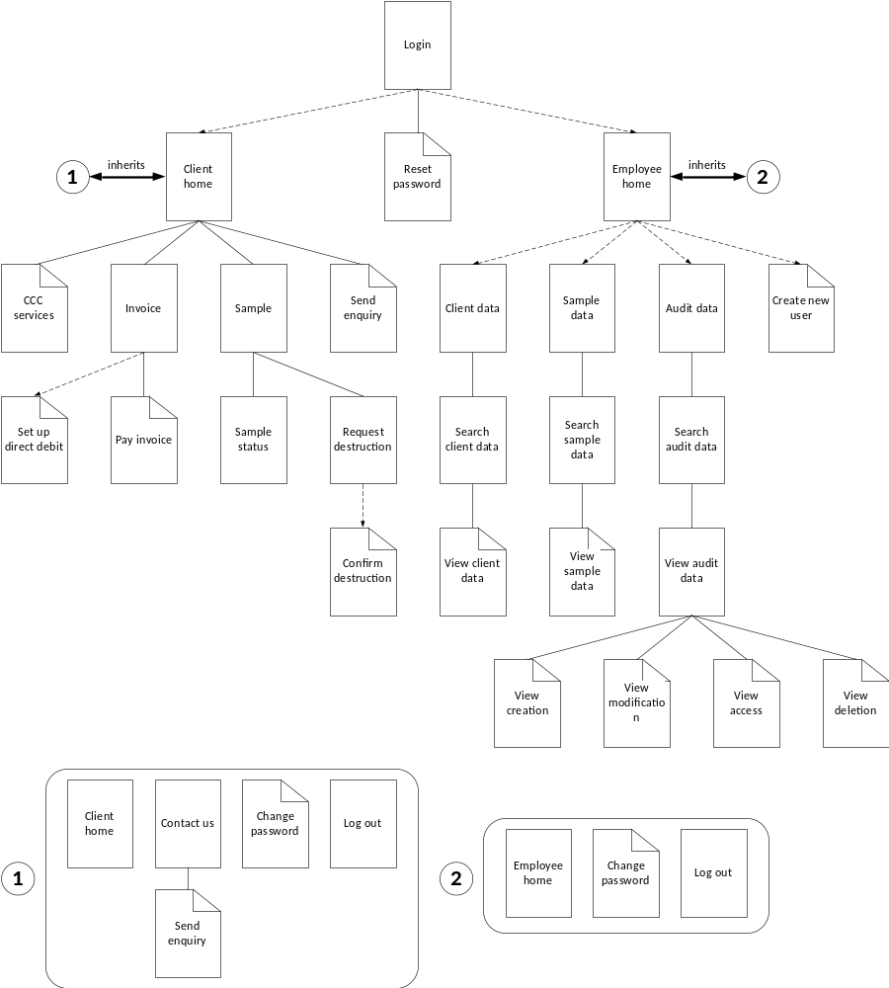

App SCREEN#1 – Log In Screen

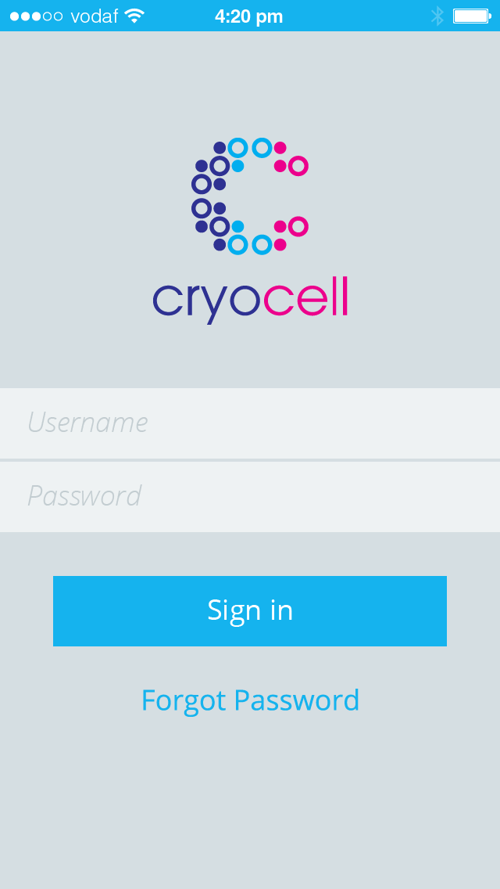

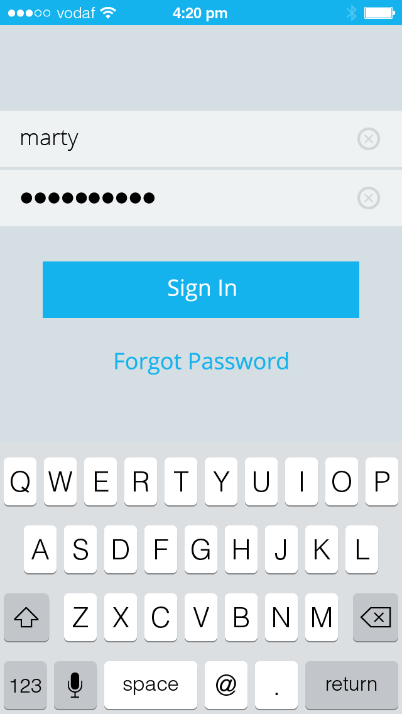

App SCREEN#2 – Client Home

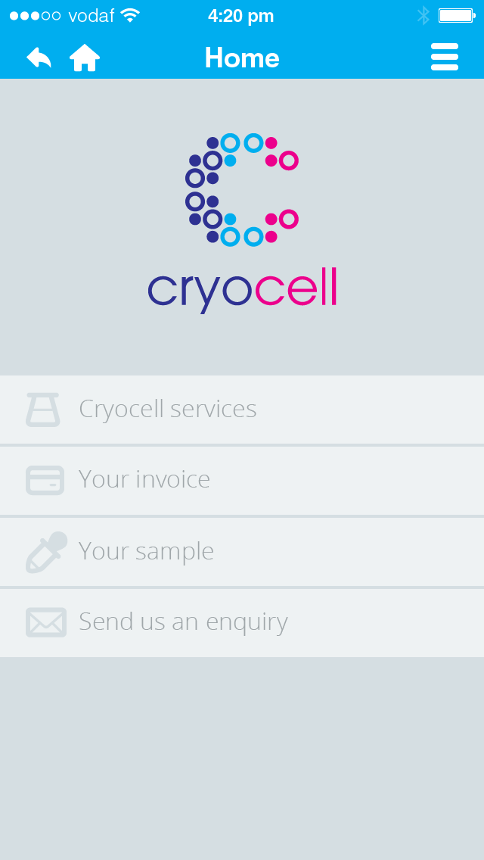

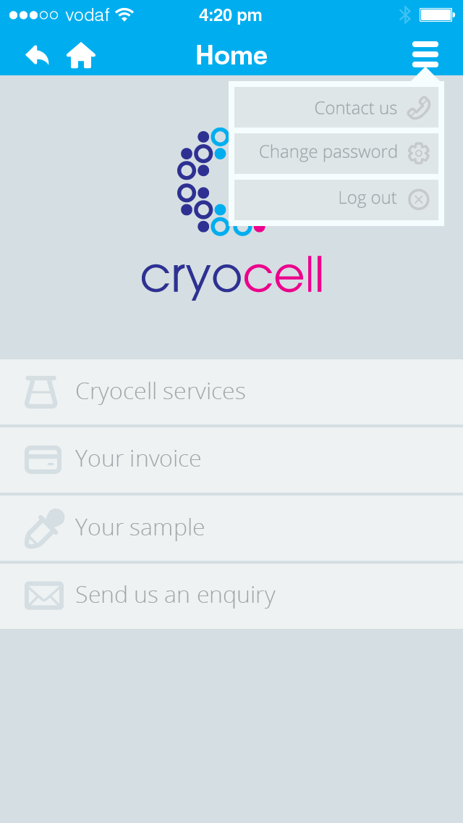

App SCREEN#3 – Lab Manager Home

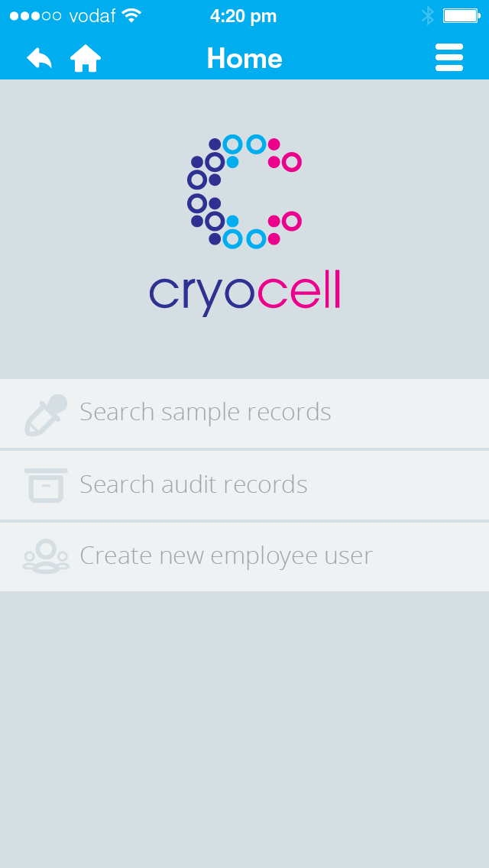

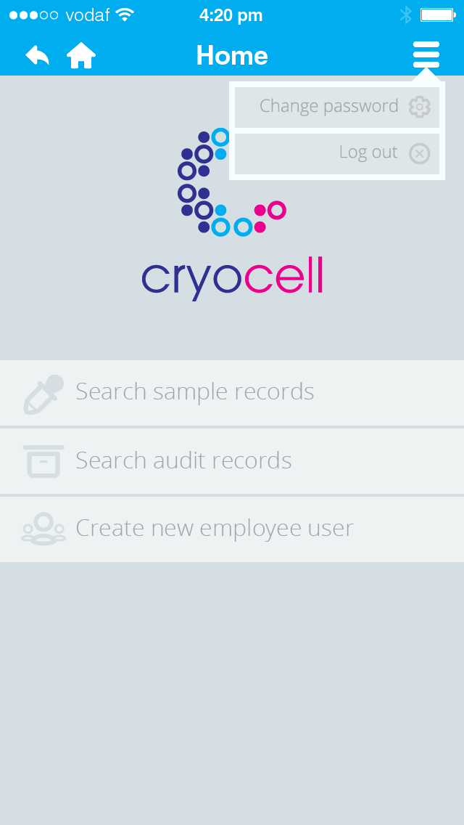

App SCREEN#4 – Search Client Results

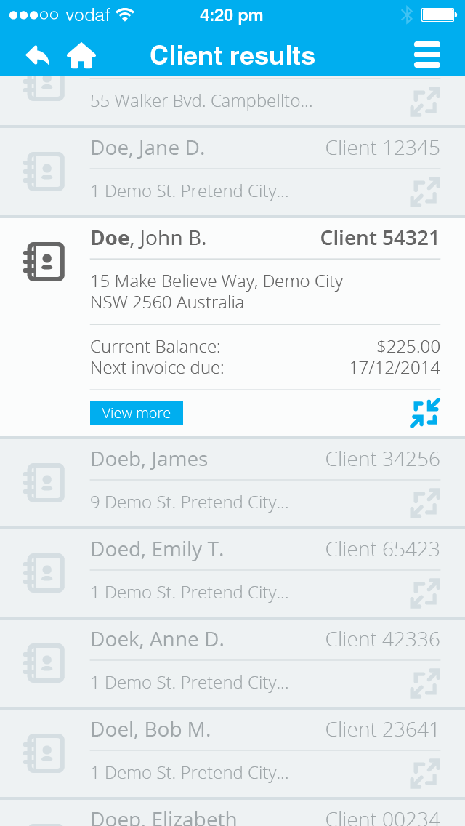

DATA DICTIONARIES

ELEMENTARY DATA DICTIONARY

Name | Type | Width  (Size) | Format | Constraint
audit-record-action | A | 8 |  | either "CREATED" or "DELETED" or "VIEWED" or "MODIFIED"
audit-record-datestamp | D | 8 | yyyymmdd
audit-record-timestamp | T | 6 | hhmmss | 24-hour time
button-back | B | 1 |  | icon = back arrow
button-clear-field | B | 1 |  | icon = cross
button-home | B | 1 |  | icon = house
button-maximise | B | 1 |  | icon = maximise
button-minimise | B | 1 |  | icon = minimize
button-more | B | 9 |  | name = View more
button-sign-in | B | 7 |  | name = Sign in
client-account-balance | N | 9 | $
client-adrs-postcode | X | 4 | 9(4)
client-adrs-state | A | 3
client-adrs-street-name | A | 15
client-adrs-street-no | X | 4 | 9(4) | No leading zeros if under 10
client-adrs-suburb | A | 20
client-adrs-unit-no | X | 4 | U + 9(2) + / | No leading zeros if under 10
client-direct-debit-status | A | 1 |  | either Y or N
client-dob | D | 10 | dd/mm/yyyy
client-email | X | 20
client-gender | A | 1 |  | either M or F
client-id | X | 5 | 9(5)
client-name-given | X | 15
client-name-surname | X | 15
client-password | X | 15
client-phone-home | X | 10 | 9(10)
client-phone-mobile | X | 10 | 9(10)
client-trustee-address | X | 12
client-trustee-adrs-postcode | X | 4 | 9(4)
client-trustee-adrs-state | A | 3
client-trustee-adrs-street-name | A | 15
client-trustee-adrs-street-no | X | 4 | 9(4) | No leading zeros if under 10
client-trustee-adrs-suburb | A | 20
client-trustee-adrs-unit-no | X | 4 | U + 9(2) + / | No leading zeros if under 10
client-trustee-dob | D | 10 | dd/mm/yyyy
client-trustee-fullname | X | 30 |  | Any X that is A, including <space>
client-trustee-phone-home | X | 10 | 9(10)
client-trustee-phone-mobile | X | 10 | 9(10)
client-username | X | 15 |  | no <space>, only special characters allowed: - or _
company-abn | X | 18 | ABN + 9(2) 9(3) 9(3) 9(3) | "ABN 32 100 201 666"
company-adrs-postcode | X | 4 | 9(4) | "2600"
company-adrs-state | A | 3 |  | "ACT"
company-adrs-street-name | X | 10 |  | "Buxton St."
company-adrs-street-no | X | 1 | 9 | "1"
company-adrs-suburb | X | 6 |  | "Deakin"
company-contact-email | X | 20
company-contact-phone | X | 10 | 9(10)
company-name | A | 21 |  | "Cryo Cell Corporation"
credit-card-csv | X | 3 | 9(3)
credit-card-expiry | D | 5 | mm/yy
credit-card-no | X | 20 | 9(4)-9(4)-9(4)-9(4)
credit-card-type | A | 1 |  | either V or M (Visa or MasterCard)
destruct-date | D | 10 | dd/mm/yyyy | date sample destruction request received
destruct-request-date | D | 10 | dd/mm/yyyy | date sample destroyed
destruct-request-received | A | 1 |  | either Y or N
employee-email | X | 20
employee-id | X | 5 | 9(5)
employee-name-given | X | 15
employee-name-surname | X | 15
employee-password | X | 15
employee-position | X | 7 |  | either "ACCTMGR" or "LABTECH" or "LABMGR"
employee-username | X | 15 |  | no <space>, only special characters allowed: - or _
invoice-due-date | D | 10 | dd/mm/yyyy
invoice-issue-date | D | 10 | dd/mm/yyyy | issue date of invoice
invoice-line-no | X | 2 | 9(2) | sequential, starting at 1, no leading zeros if under 10
invoice-no | X | 7 | 9(7)
invoice-total-cost | N | 9 | $
link-ccc-services | L | 17 |  | name = Cryocell services
link-contact-us | L | 10 |  | name = Contact us
link-create-employee-user | L | 20 |  | name = Create new employee user
link-invoice-page | L | 12 |  | name = Your invoice
link-log-out | L | 7 |  | name = Log out
link-reset-password | L | 15 |  | name = Forgot password
link-sample-page | L | 11 |  | name = Your sample
link-search-client | L | 21 |  | name = Search client records
link-search-sample | L | 21 |  | name = Search sample records
link-send-enquiry | L | 18 |  | name = Send us an enquiry
payment-type | A | 2 |  | either CC or DD (credit card or direct debit)
pulldown-client-menu | P | 1 |  | icon = 3 lines
pulldown-employee-menu | P | 1 |  | icon = 3 lines
sample-no | X | 2 | A9 | either "S1" or "S2"
sample-pickup-date | D | 10 | dd/mm/yyyy
sample-pickup-time | T | 5 | hh:mm | 24 hour time
sample-status-storage | A | 10 |  | either "DESTROYED" or "IN_STORAGE" or "IN_TRANSIT"
sample-status-test | A | 1 |  | either P or F (Pass or Fail)
sample-status-transit | A | 9 |  | either "TO_CLIENT" or "TO_CCC"
sample-storage-date | D | 8 | yyyymmdd
service-cost | N | 9 | $
service-description | X | 40 |  | either Initial test, Annual storage fee (in advance)
service-id | X | 2 | 9(2)
service-name | X | 7 |  | either "TEST" or "STORAGE"
statement-date-end | D | 10 | dd/mm/yyyy | end of invoice period
statement-date-start | D | 10 | dd/mm/yyyy | start of invoice period
storage-csc-matrix | X | 2 | 9(2) | No leading zeros if under 10
storage-csc-no | X | 5 | A(3) + 9(2) | CSC99
storage-facility | A | 3 |  | First three characters of city ie. PER
storage-fridgeid | X | 3 | A + 9(2) | F99
title-client-page | A | 20 |  | either "Home", "Services", "Invoice", "Pay invoice", "Sample", "Sample status", "Request destruction", "Confirm destruction"
title-employee-page | A | 20 |  | either "Home", "Client data", "Client search", "Client", "Sample data", "Sample search", "Sample", "Audit data", "Audit search", "Audit", "Creation", "Modification", "Access", "Deletion", "New user"

Legend:
A | Alphabetic
N | Numeric
9 | Any digit
X | Any character
D | Date format (dd/mm/yyyy)
$ | Leading spaces
Z | Leading blank or any digit
T | Time
L | Link
B | Button
P | Pulldown menu

COMPOSITE DATA DICTIONARY

Recurring composite definitions

sample-id = sample-no + sample-storage-date + {storage-id}

storage-id = storage-facility + storage-fridgeid + storage-csc-no + storage-csc-matrix

client-address-long = client-adrs-street-no + client-adrs-street-name + client-adrs-suburb + client-adrs-state + client-adrs-postcode

employee-nav-bar = button-back + button-home + title-employee-page + {pulldown-employee-menu}

pulldown-employee-menu = link-reset-password + link-log-out

App screen composite definitions

Login

login-screen = [client-username | employee-username] + (button-clear-field) + [client-password | employee-password] + (button-clear-field) + button-sign-in + link-reset-password

Client home

client-home = {client-nav-bar} + link-ccc-services + link-invoice-page + link-sample-page + link-send-enquiry

client-nav-bar = button-back + button-home + title-client-page + {pulldown-client-menu}

pulldown-client-menu = link-contact-us + link-reset-password + link-log-out

Lab Manager home

lab-manager-home = {employee-nav-bar} + link-search-client + link-search-sample + link-search-audit + link-create-employee-user

Search client results

search-client-results = {employee-nav-bar} + 1{client-record-line}
client-record-line = {client-identifier} + [{client-address-short} | {client-address-long}] + (client-account-balance) + (invoice-due-date) + (button-more) + [button-maximise | button-minimize]

client-identifier client-name-surname + client-name-given + client-id

client-address-short = client-adrs-street-no + client-adrs-street-name + client-adrs suburb

Invoice view

Invoice-view = {invoice-header} + {sample-id} + {statement-date} + 1{invoice-line} + invoice-total-cost

invoice-header = {company-details} + {invoice-details} + {client-details}

company-details = {company-address} + company-abn

invoice-details = invoice-issue-date + invoice-no + invoice-due-date

company-details = company-name + {company-address}

company-address = company-adrs-street-no + company-adrs-street-name + company-adrs-suburb + company-adrs-state + company-adrs-postcode

client-details = client-name-given + client-name-surname + {client-address-long} + client-id

statement-date = statement-date-start + statement-date-end

invoice-line = invoice-line-no + service-description + service-cost

Entity composite definitions

CLIENT

CLIENT = {client-record}

client-record = client-id + client-username + client-password + client-name-surname + client-name-given + client-dob + client-gender + client-direct-debit-status + client-email + client-phone-home + client-phone-mobile + {client-address-long} + sample-no + {sample-id*} + credit-card-no*

CLIENT TRUSTEE

CLIENT TRUSTEE = {client-trustee-record}

client-trustee-record = client-trustee-fullname + client-trustee-dob + client-trustee-phone-home + client-trustee-phone-mobile + {client-trustee-address} + client-id*

client-trustee-address = client-trustee-adrs-unit-no + client-trustee-adrs-street-no + client-trustee-adrs-street-name + client-trustee-adrs-suburb + client-trustee-state + client-trustee-postcode

EMPLOYEE

EMPLOYEE = {employee-record}

employee-record = employee-id + employee-username + employee-password + employee-position + employee-name-surname + employee-name-given

SAMPLE

SAMPLE = {sample-record}

sample-record = {sample-id} + sample-storage-date + sample-status-test + sample-status-storage + sample-status-transit + sample-pickup-date + sample-pickup-time + storage-id + client-id*

STORAGE

STORAGE = {storage-record}

storage-record = {storage-id} + storage-facility + storage-fridgeid + storage-csc-no + storage-csc-matrix

SERVICE

SERVICE = {service-record}

service-record = service-id + service-name + service-description + service-cost + {sample-id*}

SAMPLE DESTRUCTION

SAMPLE DESTRUCTION = {sample-destruction-record}

sample-destruction-record = client-id + {sample-id} + destruct-request-received + destruct-date + destruct-request-date

CREDIT CARD

CREDIT CARD = {credit-card-record}

credit-card-record = credit-card-no + credit-card-csv + credit-card-expiry + credit-card-type + payment-type + client-id*

AUDIT RECORD

AUDIT RECORD = {audit-unit}

audit-unit = {audit-record-no} + audit-record-datestamp + audit-record-timestamp + audit-record-action + client-id* + {sample-id*} + employee-id*

audit-record-no = audit-record-datestamp + audit-record-timestamp + employee-id + audit-record-action

INVOICE LINE

INVOICE LINE = {invoice-line-record}

invoice-line-record = invoice-no + invoice-line-no + {sample-id*} + service-id*

INVOICE

INVOICE = {invoice-record}

invoice-record = invoice-no + invoice-issue-date + invoice-due-date + statement-date-start + statement-date-end + client-id* + {sample-id*}

BUSINESS RULES DIAGRAMS

BRD OF LOG IN TO APPLICATION

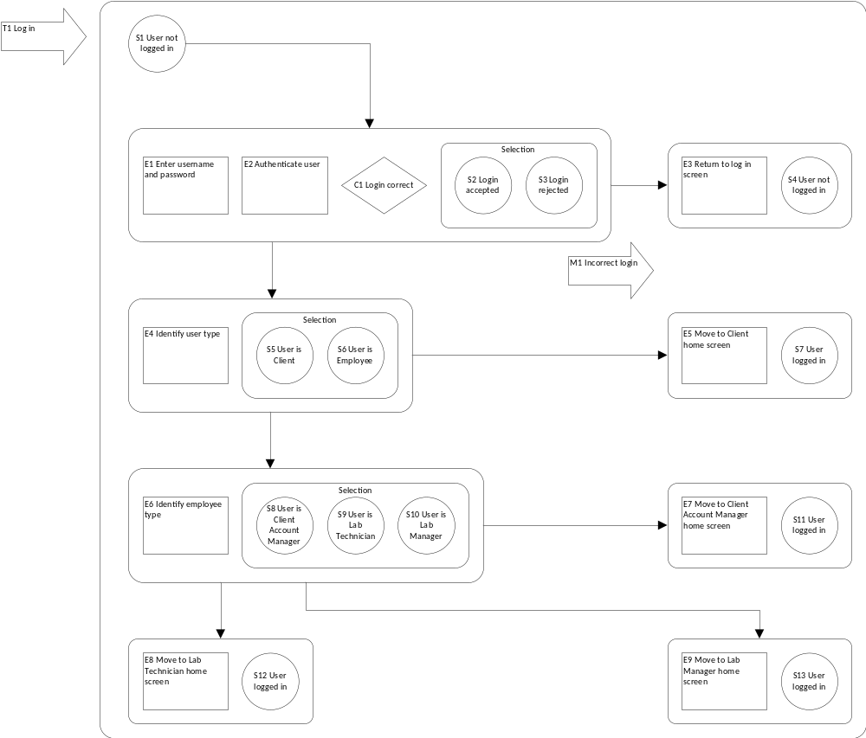

EVENT SPECIFICATION TABLE OF LOG IN TO APPLICATION

Event | Trigger | Message | Condition | Pre-state | Post-state | Rule
E1 | T1 |  |  | S1 | S2 | S3 | 3.2.1 & 3.2.2
E2 |  |  |  | S1 | S2 | S3 | 3.2.1 & 3.2.2
E3 |  | M1 | !C1 | S3 | S4 | 3.2.1 & 3.2.2
E4 |  |  | C1 | S2 | S5 | S6 | 3.2.1 & 3.2.2
E5 |  |  |  | S5 | S7 | 3.2.1
E6 |  |  |  | S6 | S8 | S9 | S10 | 3.2.2
E7 |  |  |  | S8 | S11 | 3.2.2
E8 |  |  |  | S9 | S12 | 3.2.2
E9 |  |  |  | S10 | S13 | 3.2.2

Corresponding rules: Non-Functional Requirements

3.2.1 Existing Client user must be able to log in to the application using their CCC client user account login details.

3.2.2 Existing CCC Employee user must be able to log in to the application using their employee user account login details.

BRD OF SEARCH CLIENT RECORDS

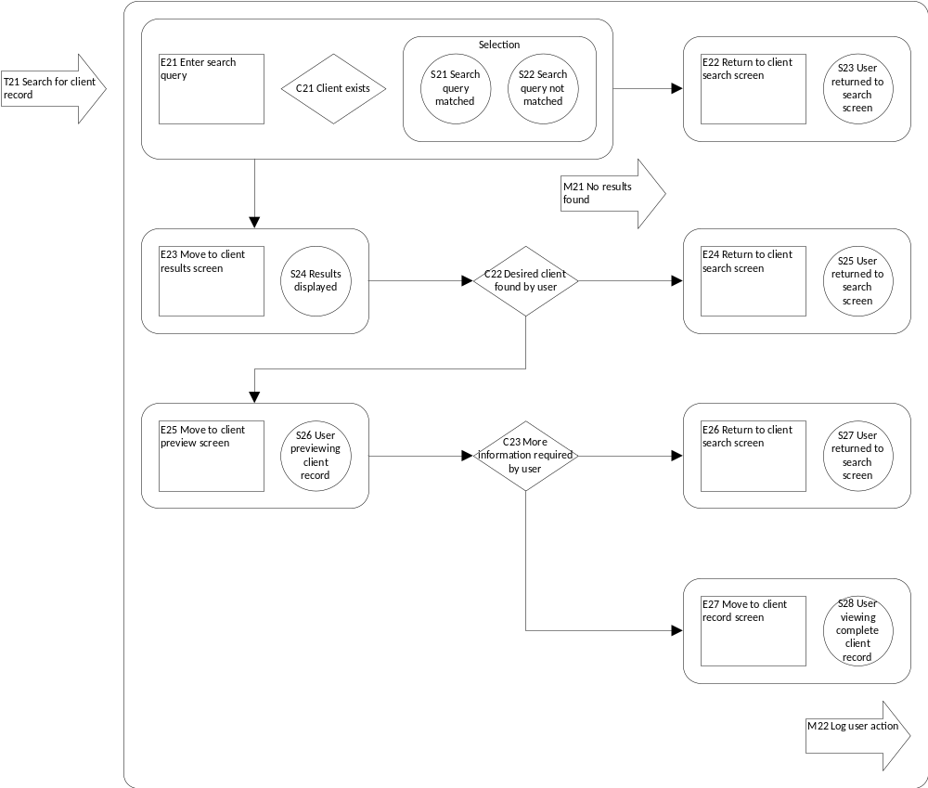

EVENT SPECIFICATION TABLE OF SEARCH CLIENT RECORDS

Event | Trigger | Message | Condition | Pre-state | Post-state | Rule
E21 | T21 |  |  |  | S21 | S22 | 3.1.5
E22 |  | M21 | !C21 | S22 | S23 | 3.1.5
E23 |  |  | C21 | S21 | S24 | 3.1.5
E24 |  |  | !C22 | S24 | S25 | 3.1.5
E25 |  |  | C22 | S24 | S26 | 3.1.5
E26 |  |  | !C23 | S26 | S27 | 3.1.5
E27 |  | M22 | C23 | S26 | S28 | 3.1.5

Corresponding rules: Functional Requirements

3.1.5 Client Account Manager must be able to view client records only.

BRD OF VIEW INVOICE

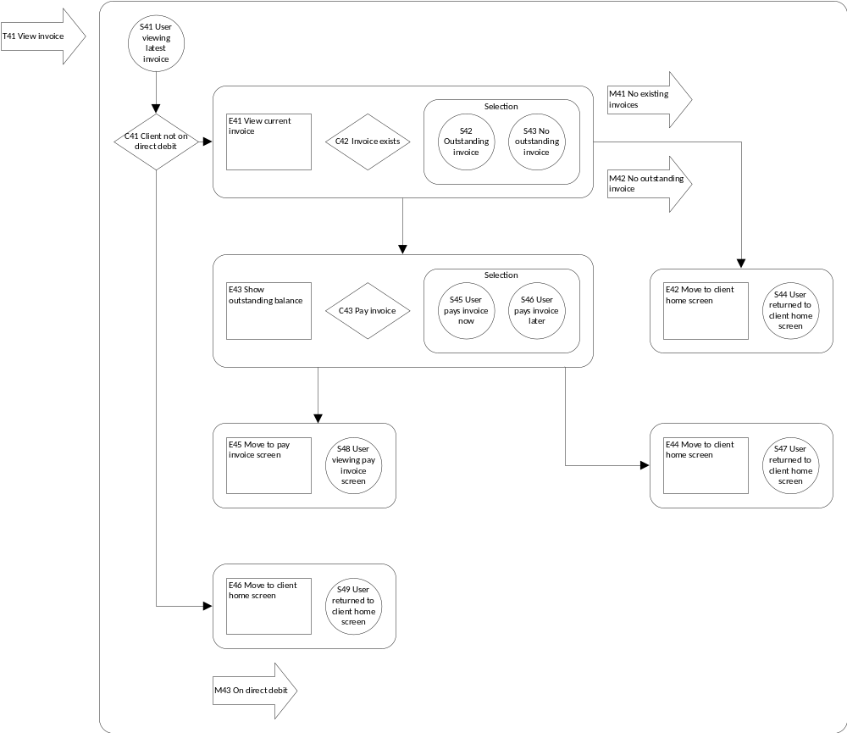

EVENT SPECIFICATION TABLE OF VIEW INVOICE

Event | Trigger | Message | Condition | Pre-state | Post-state | Rule
E41 | T41 |  | C41 | S41 | S42 | S43 | 3.1.4
E42 |  | M41 | !C42 | S43 | S44 | 3.1.4
E42 |  | M42 | C42 | S43 | S44 | 3.1.4
E43 |  |  | C42 | S42 | S45 | S46 | 3.1.4
E44 |  |  | !C43 | S46 | S47 | 3.1.4
E45 |  |  | C43 | S45 | S48 | 3.1.4
E46 |  | M43 | !C41 | S41 | S49 | 3.1.4

Corresponding rules: Functional Requirements

3.1.4 Client must be able to securely view and pay invoices from CCC.

BRD OF PAY INVOICE

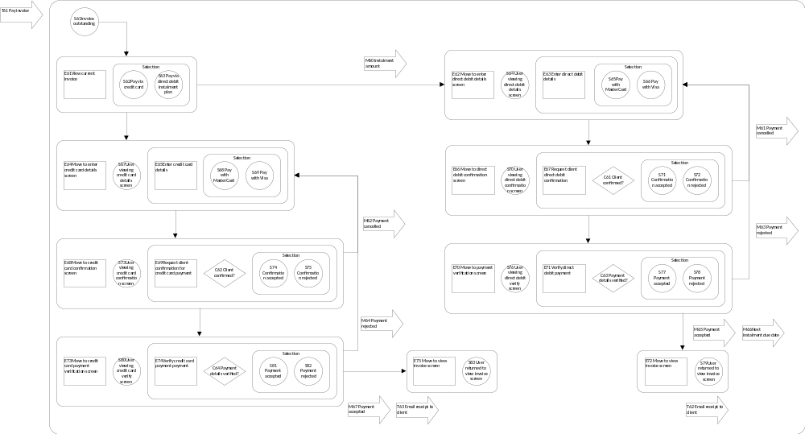

EVENT SPECIFICATION TABLE OF PAY INVOICE

Event | Trigger | Message | Condition | Pre-state | Post-state | Rule
E61 | T61 |  |  | S61 | S62 | S63 | 3.1.4 & 3.2.3 & 3.2.5
E62 |  | M60 |  | S63 | S64 | 3.2.5 & 4.1.13
E62 |  | M61 | !C61 | S72 | S64 | 3.2.5 & 4.1.13
E62 |  | M63 | !C63 | S78 | S64 | 3.2.5 & 4.1.13
E63 |  |  |  | S64 | S65 | S66 | 3.2.5 & 4.1.13
E64 |  |  |  | S62 | S67 | 3.2.3 & 3.2.4
E64 |  | M62 | !C62 | S75 | S67 | 3.2.3 & 3.2.4
E64 |  | M64 | !C64 | S82 | S67 | 3.2.3 & 3.2.4
E65 |  |  |  | S67 | S68 | S69 | 3.2.3 & 3.2.4
E66 |  |  |  | S65 | S66 | S70 | 3.2.5 & 4.1.13
E67 |  |  |  | S70 | S71 | S72 | 3.2.5 & 4.1.13
E68 |  |  |  | S68 | S69 | S73 | 3.2.3 & 3.2.4
E69 |  |  |  | S73 | S74 | S75 | 3.2.3 & 3.2.4
E70 |  |  | C61 | S70 | S76 | 3.2.5 & 4.1.13
E71 |  |  |  | S76 | S77 | S78 | 3.2.5 & 4.1.13
E72 | T62 | M65 & M66 | C63 | S77 | S79 | 3.2.5 & 4.1.13
E73 |  |  | C62 | S74 | S80 | 3.2.3 & 3.2.4
E74 |  |  |  | S80 | S81 | S82 | 3.2.3 & 3.2.4
E75 | T63 | M67 | C64 | S81 | S83 | 3.2.3 & 3.2.4

Corresponding rules: Functional Requirements

3.1.4 Client must be able to securely view and pay invoices from CCC.

Corresponding rules: Non-Functional Requirements

3.2.3 Client must be able to pay invoice via credit card.

3.2.4 Credit card payment is only accepted via MasterCard or Visa.

3.2.5 Client must be able to select direct debit payment method.

Corresponding rules: Assumptions

4.1.13 It is assumed that direct debit payments are only accepted via credit card, MasterCard or Visa.

BRD OF REQUEST SAMPLE DESTRUCTION

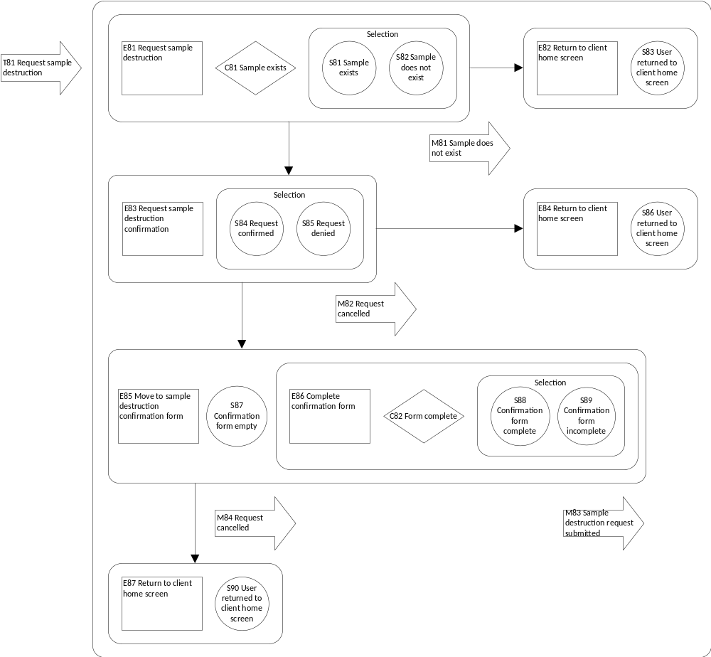

EVENT SPECIFICATION TABLE OF REQUEST SAMPLE DESTRUCTION

Event | Trigger | Message | Condition | Pre-state | Post-state | Rule
E81 | T81 |  |  |  | S81 | S82 | 3.1.2
E82 |  | M81 | !C81 | S82 | S83 | 3.1.2
E83 |  |  | C81 | S81 | S84 | S85 | 3.1.2
E84 |  | M82 |  | S85 | S86 | 3.1.2
E85 |  |  |  | S84 | S87 | 3.1.2
E86 |  |  |  | S87 | S88 | S89 | 3.1.2
E87 |  | M84 | !C82 | S89 | S90 | 3.1.2
E87 |  | M83 | C82 | S88 | S90 | 3.1.2

Corresponding rules: Functional Requirements

3.1.2 Client must be able to request their sample to be destroyed.

REFERENCES

Cryo Cell Case Study.doc

Corona SDK, retrieved on August 20, from http://coronalabs.com/products/corona-sdk/

Australian Privacy Principles, retrieved on August 29, from http://www.oaic.gov.au/privacy/privacy-act/australian-privacy-principles

Perdue, Blake (2014), iOS 7 Wireframe kit, retrieved on September 26, from http://blakeperdue.com/ios7-wireframe-kit/

Hutchings, Stephen (2014), Typicons, retrieved on September 26, from http://www.flaticon.com/packs/typicons

LOGICAL RELATIONAL DATA MODEL

